General Plan of the Projet :

JAVA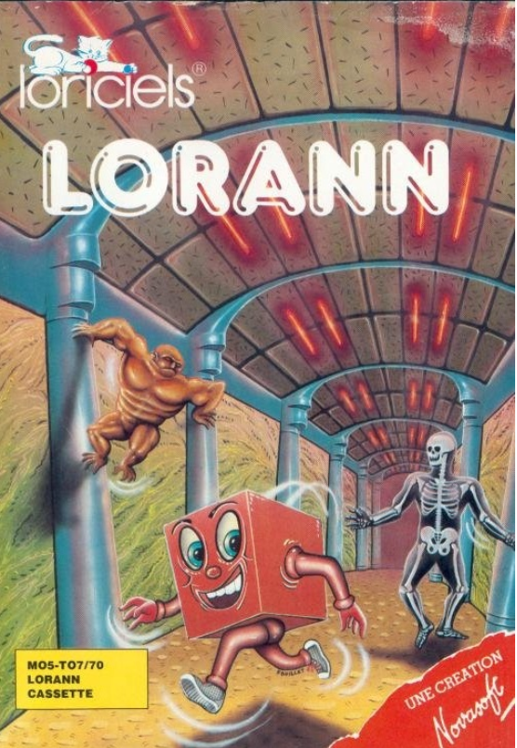

2017-2018

Jean-Gabriel Dron – Hugo Dimoff – Mickael Michel – Gilles Loumouamou

Cesi.Exia Nancy

2017-2018

Table des matières

I-/ Introduction to the subject: 2

II-/ Needs: 3

III-/ Functional Requirements : 3

V-/ Choice of Software: 4

VI-/ Perspectives of evolution: 6

VII-/ Problems encountered: 6

VIII-/ Appraisal : 6

A) Appraisal of the team : 6

B) Personnal appraisal : 6

IX-/ Conclusion : 7

# I-/ Introduction to the subject:

It's about rewriting an old game (1985) LORANN de Loriciels. This game was originally published for MO5 and TO7 (names that probably evoke nothing for you, but for bearded computer scientists represent a part of their childhood and their discovery of computers).

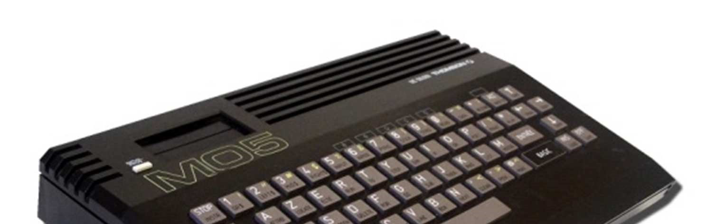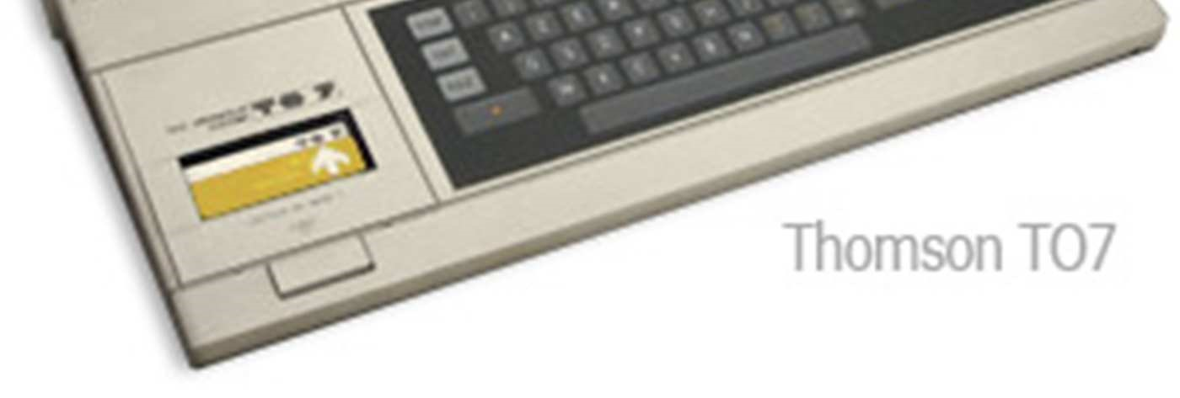

LORANN is a PacMan type game, that is to say that a character moves from box to box trying to collect a maximum of objects without being caught by 4 monsters in 101 levels. No super pacgom, but a spell that the character can launch to kill his attackers. The difficulty is that it only has one spell. The only way to get a new one is to kill a monster or pick up the previous one. Nothing fancy then, but in 1985, this game provided many children (including me) many hours of fun.

The best thing is that you try the game to better understand it. For this you just need to install a Thomson emulator and launch the game ROM. Both are available in the resources.

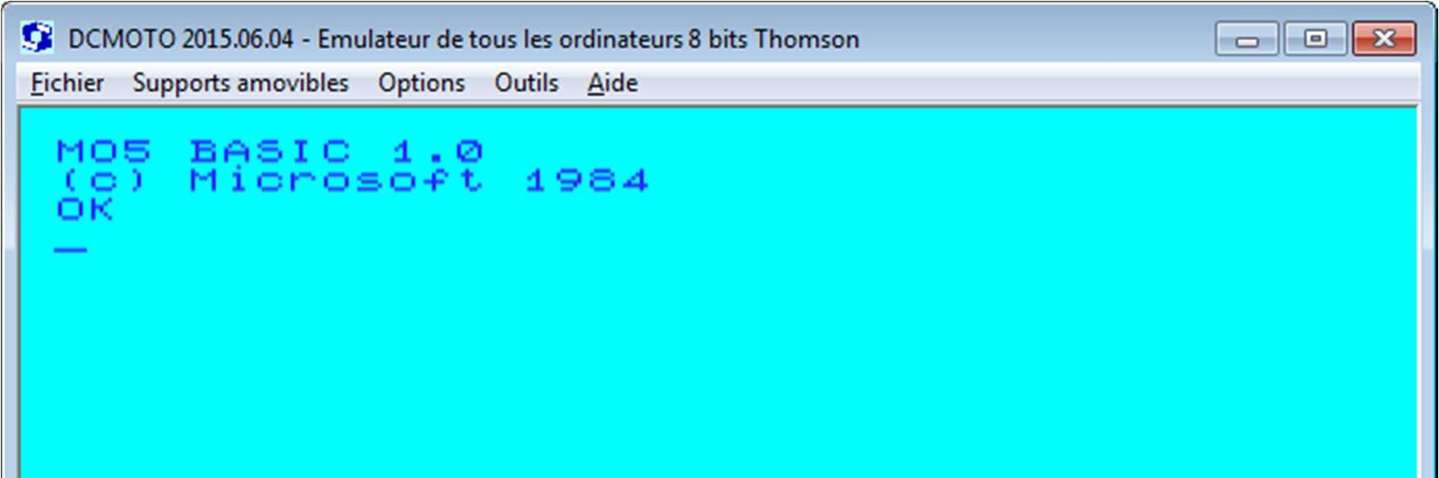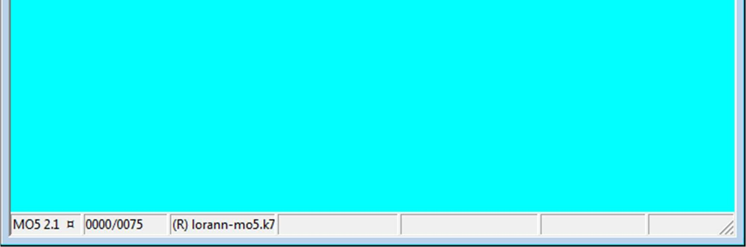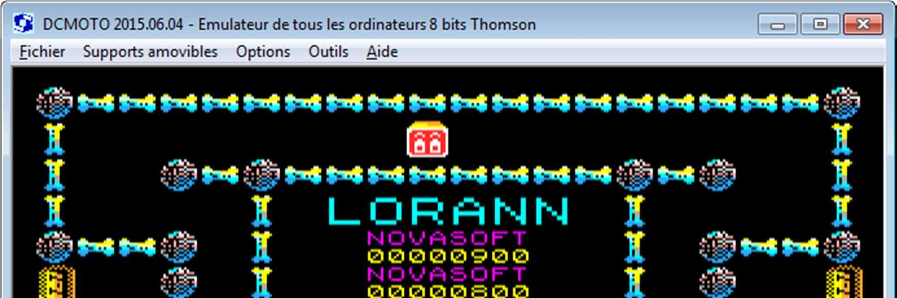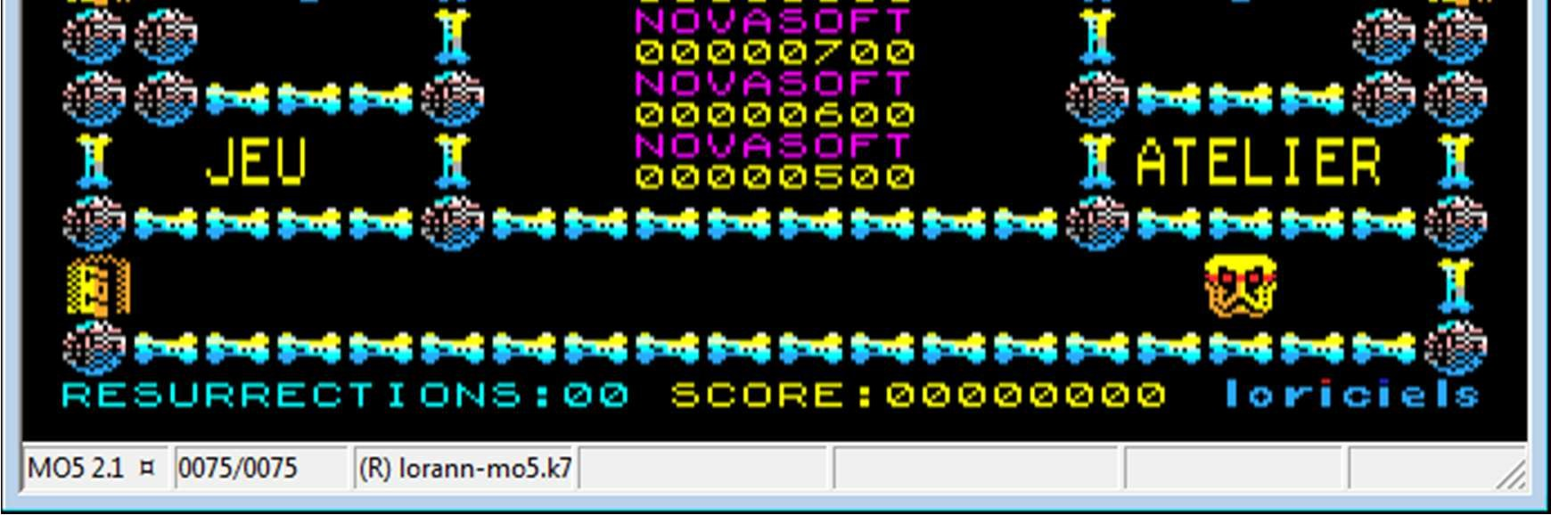

# II-/ Needs:

For this project the needs are as follows:

- Make several class diagram (5 / one per package)

- Link a database with a java program

- Control the character through 5 different levels

- Have a clean JavaDoc

- Have functional TDDs

- Manage everything with GitHub

# III-/ Functional Requirements :

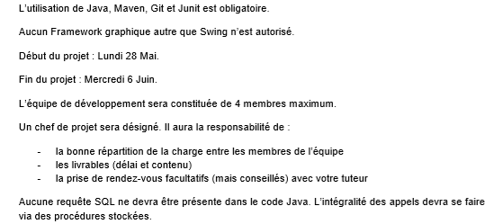

# V-/ Choice of Software:



Eclipse is a programming IDE for JAVA codes



Word is word processing software that was used to do the technical doxumentations



Github Desktop is a software that allowed us to put the code in our directory github while having made our modifications under eclipse



phpmyadmin is the software on which your database is stored



Github is the site where all our code is copied so that everyone can access it



Visual Paradigm is the software on which we made all our modeling of the different UML language diagram that we had to render.



PowerPoint is the software on which we made our slideshow

# VI-/ Perspectives of evolution:

For our evolution perspective we hope to integrate the maps that are stored in the database. We would like to be able to manage the collisions and display the monsters with their different algorithms in order to display them in the windows.

# VII-/ Problems encountered:

As for the problems we encountered, we had a lot of them.

Lack of time and problem in writing the code on eclipse.

Problem with the Maven architecture.

# VIII-/ Appraisal :

## Appraisal of the team :

Complicated project for the whole group despite a good general agreement.

## Personnal appraisal :

Hugo DIMOFF :

Despite the revision on the database a project that was difficult to achieve with my knowledge

Gilles LOUMOUAMOU :

There was a good agreement between us, I think you worked well but the project is not finished despite our efforts

Mickael MICHEL :

It was a good project, despite some difficulties, I have the feeling to have do a progress in JAVA, MAVEN and the UML was the big problem for me.

However, I liked this project and work together, the ambience was pleasant !

Jean-Gabriel DRON :

Long and difficult project despite a group with a good general agreement

# IX-/ Conclusion :

Despite a good understanding, the project is not over due to the many difficulties encountered throughout the project.